Media Release
Feb. 14, 2019

Actor Michael K. Williams from “The Wire” joins Mayor Thomas to showcase Mount Vernon art and business

NEW YORK CITY – Actor Michael K. Williams of “The Wire” Mayor Richard Thomas celebrated Mount Vernon’s talent and businesses Wednesday night at a commemoration of the transatlantic slave trade.

The Black History Month event at the Kosciuszko Foundation was designed to educate members of New York’s African community about business and residential opportunities in Mount Vernon.

Williams, known for his roles in “Boardwalk Empire” and “Twelve Years a Slave,” said he was celebrating.

“Tonight, we’re going to celebrate culture. We’re going to celebrate perseverance and spirit, community. The story of the African, it transcends now. It’s not just black history, it’s American history,” said Williams.

In his remarks related to the transatlantic slave trade, Mayor Thomas said that the hardships of the past should not dictate the present.

“Tonight’s about not living for the past but living for the future,” said Mayor Thomas. “I’m proud and privileged to be someone that came from very little to give a lot to people that are going to do a lot more for the future.”

Mayor Thomas also called on the attendees to have impatience and a sense of urgency when pursuing goals or seeking positive change.

“Think about your grandparents 100 years ago. They weren’t checking their phones or who texted them.…They were thinking about how to survive,” said Mayor Thomas. “And the little bit of power we have, we have to make sure we point it in the right direction, and that’s forward.”

The Kosciuszko Foundation is dedicated to promoting educational and cultural exchanges between the United States and Poland and to increase American understanding of Polish culture and history.

Peter Novak, the foundation’s treasurer and a member of the Mount Vernon Sports Board, invited Mayor Thomas to host an event at the foundation because Andrew Thaddeus Bonaventure Kosciuszko, a hero of the American Revolution, was an early advocate of abolition. Novak noted that Polish culture and African American culture both have histories of oppression.

“Our histories have been unfortunately not been very positive,” Novak said. “We have to push aside what happened in the past and only focus on what’s in the future.”

Williams told the crowd that he was not aware of Kosciuszko’s anti-slavery advocacy until last night.

“That story tonight it taught me that the ability and desire to do the right thing transcends color. The ability to feel empathy for another human being transcends race,” said Williams.
Last night’s event included a large exhibition of arts and crafts from the Mount Vernon-based Luangisa African Gallery. The business was founded by members of the Luangisa family from Bukoba, Tanzania.

The gallery promotes fair trade and it sells modern African art, crafts, home décor and jewelry.

Teenagers from the Mount Vernon Youth Bureau also attended the event and one of them performed a dance.

Photos: https://www.dropbox.com/sh/86qbayxysm4spge/AAA8AI74y9DU02rRRDlOK5iHa?dl=0

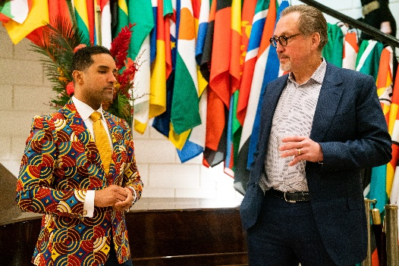
Caption: Mount Vernon Mayor Richard Thomas, left, with Peter Novak, treasurer of the Kosciuszko Foundation in New York City.

Video: https://www.dropbox.com/s/78xzvxb647ihchd/MICHAEL-K-ADDRESS-DRAFT1.mp4?dl=0

********************

